**ASSIGNMENT 13**

**Introduction to Networking, Footprinting using reconnaissance enumeration**

# **INDEX**

|  |  |  |
| --- | --- | --- |
| **SL NO** | **TOPIC** | **PAGE NO** |
| 1. | Summary report on different steps performed on Brooklyn99 | 2-9 |
| 2. | Summary report on different steps performed on Linux Fundamentals | 9-10 |

# **Topic: STEPS PERFORMED ON BROOKLYN NINE NINE AND LINUX FUNDAMENTALS (TRYHACK ME)**

ASSIGNMENT 13(DAY 15) Date:13-07-2022

1. **Summary report on different steps performed on Brooklyn Nine Nine**

**Step 1:**

**Brooklyn Nine Nine room was solved today on tryhackme. At first, the machine was started and we copied the IP Address which was provided by Tryhackme for port scanning then we opened the attackbox.**

**Step 2:**

**Initially we created a folder name Brooklyn99 in the desktop, and inside that folder we created 2 more folder as Web and Nmap.Then on the terminal in order to port scan we used the command nmap -sC -Sv -A -p- 10.10.99.206 -oN nmap/ports_details.txt**

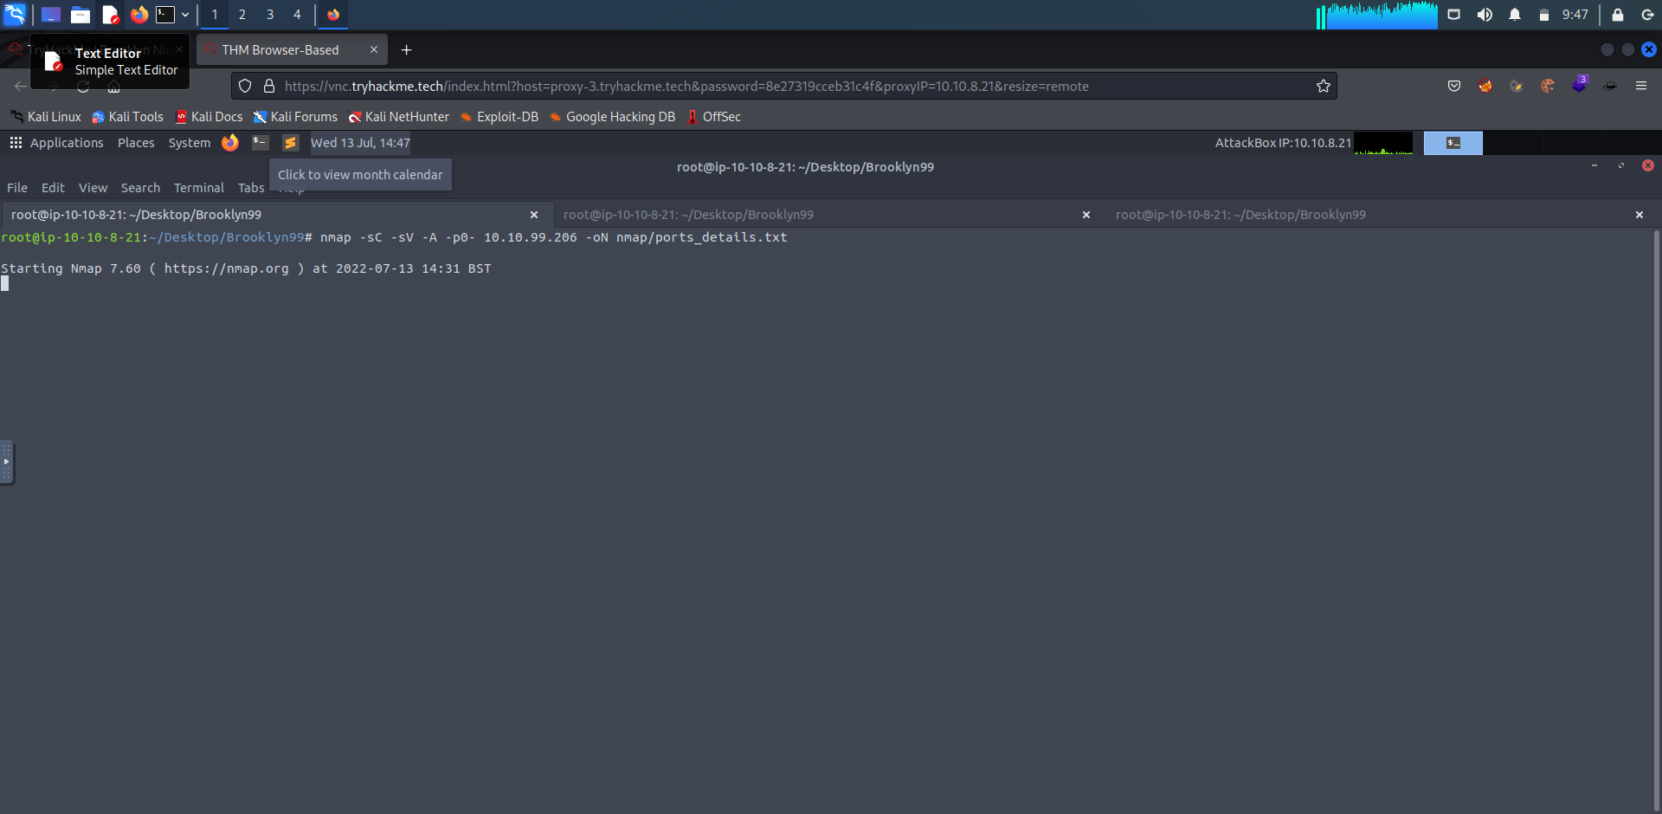

**Step 3:**

**Then we again performed another scan using command nmap -sV 10.10.99.206**

**-oN nmaps/ports.txt and we got the following results.**

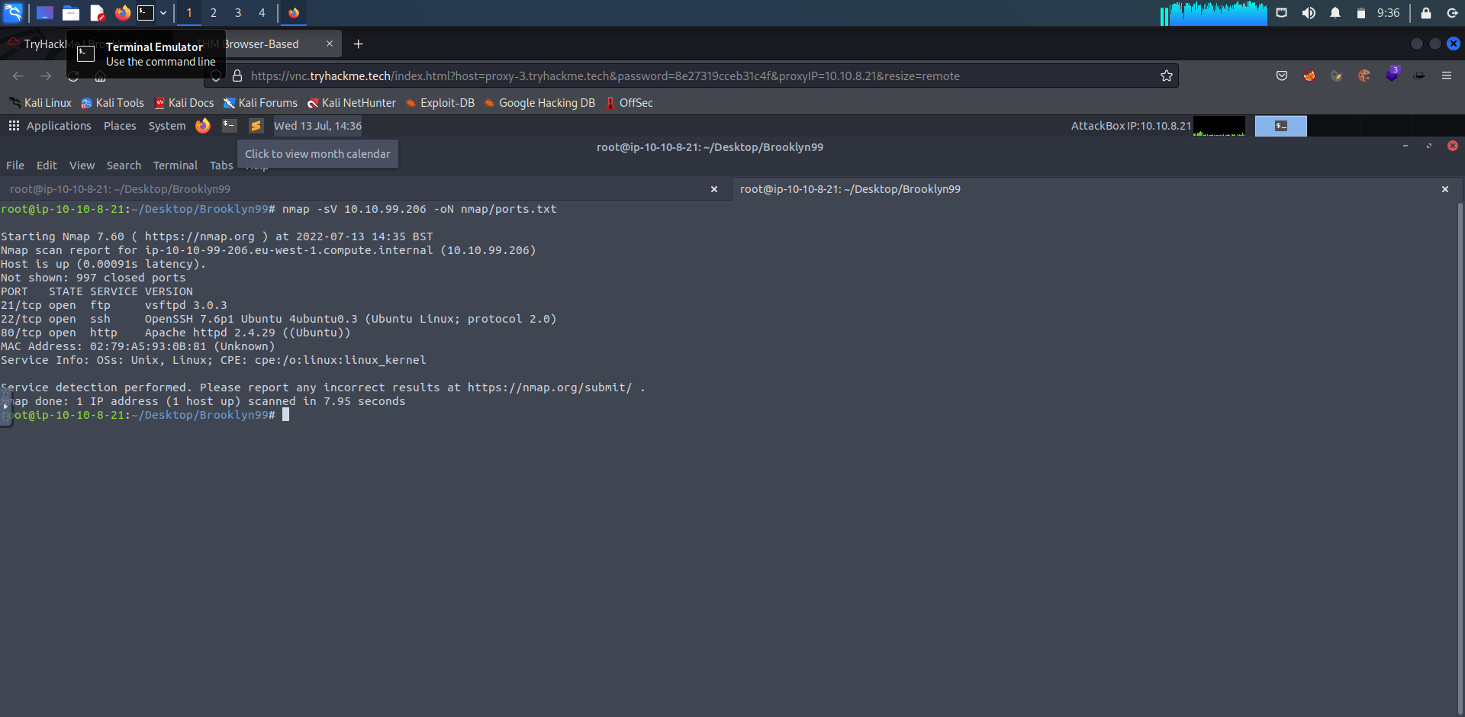

**Step 4:**

**In the previous nmap scan we found that the 21,22,80 ports are open, so in order to find more information about the ports we used the command nmap -A -p 21,22,80 10.10.99.206 and we got the following output.**

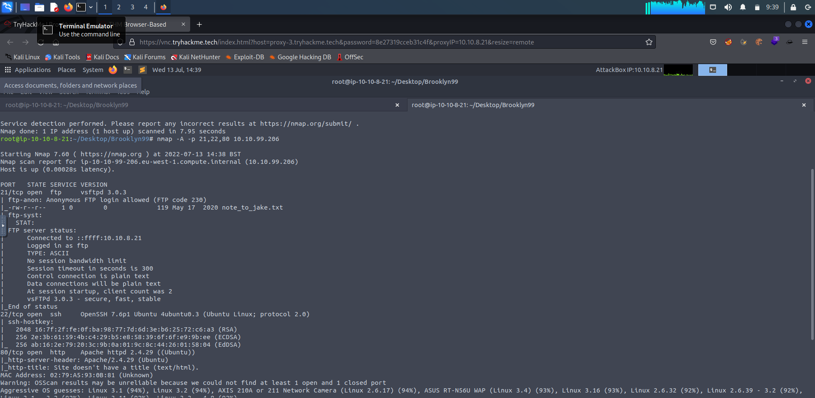

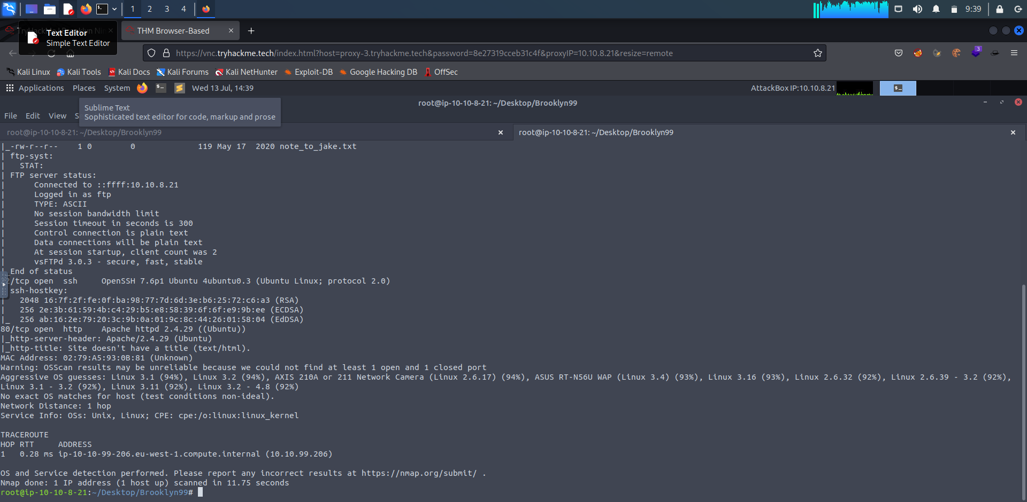

**Step 5:**

**Now another scan was done to check for anonymous** [**ftp. For**](ftp://ftp.For) **this we used the command ftp 10.10.99.206. And here the username was anonymous. We found that anonymous ftp is available on this site. Then using ls command we saw the contents and then we used get note_to_jake.txt command.**

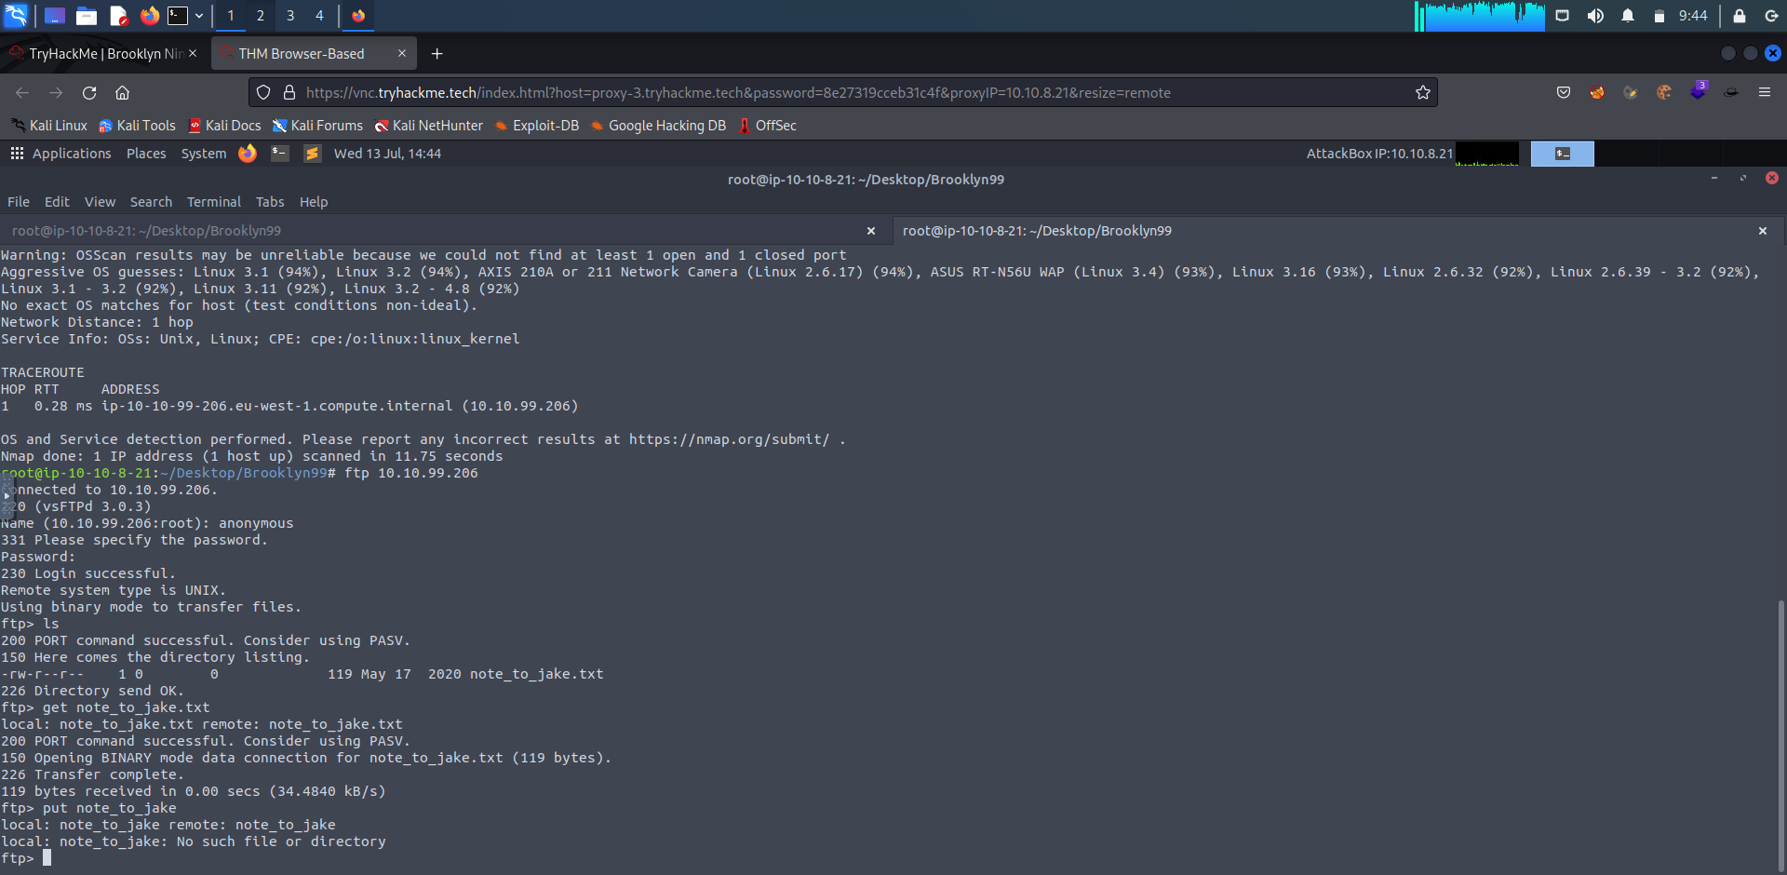

**Step 6:**

**Now we visited the IP Address and we found that there was an image. Then we saved the image in the web folder and then using the command cat note_to_jake.txt we got the following message.**

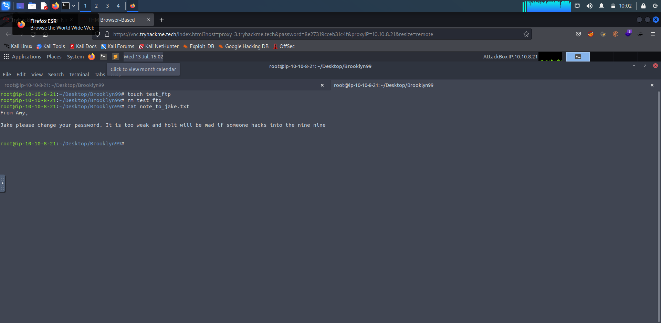

**Then using subl Readme.md command we made the following notes from the above displayed message.**

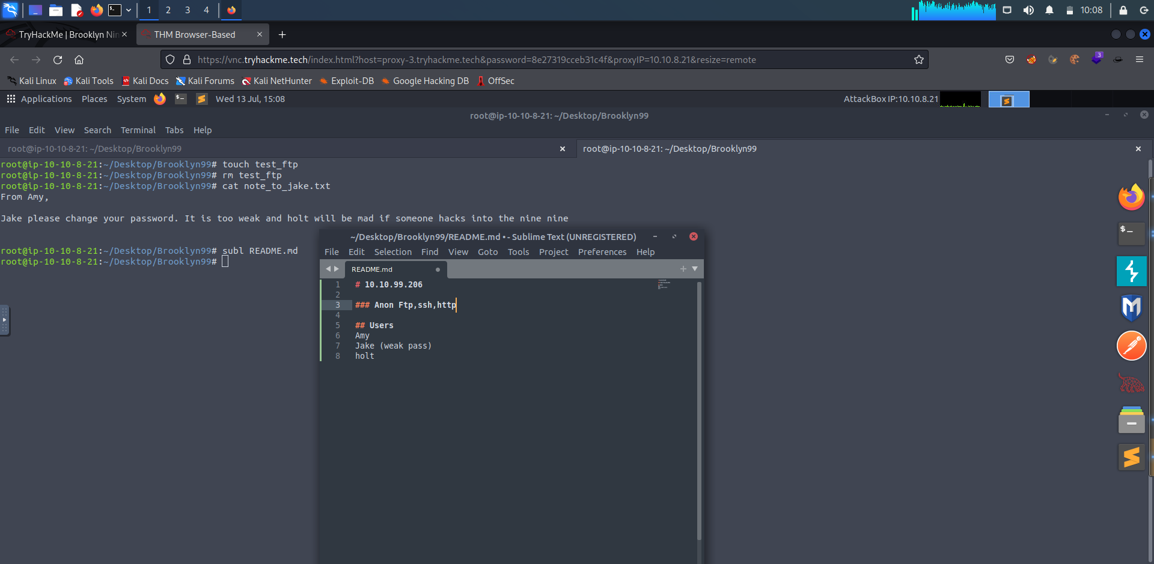

**Step 7:**

**Then we downloaded the exiftool in order to check the file is steganographic file or not.**

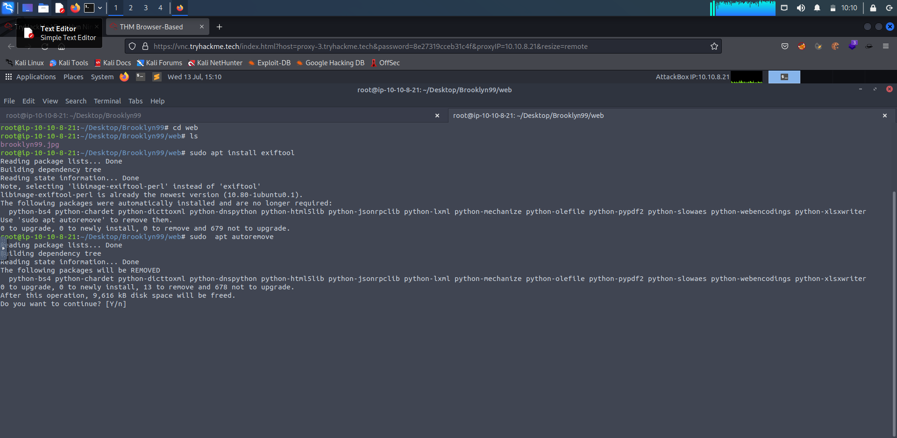

**Step 8:**

**Then we downloaded autoremove tool.**

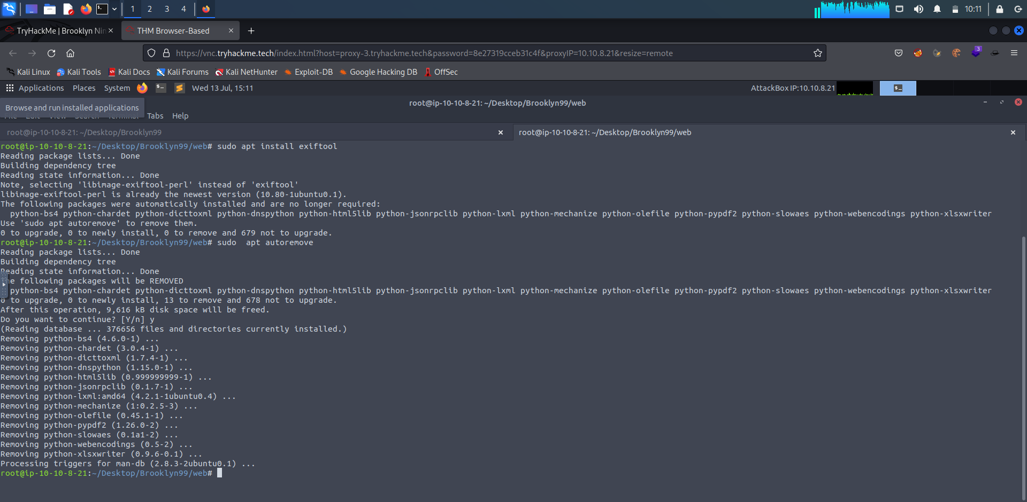

**Step 9:**

**With the help of help command we found the details of exiftool.Then using command exiftool -e brooklyn99.jpg we got the following information about the downloaded image.**

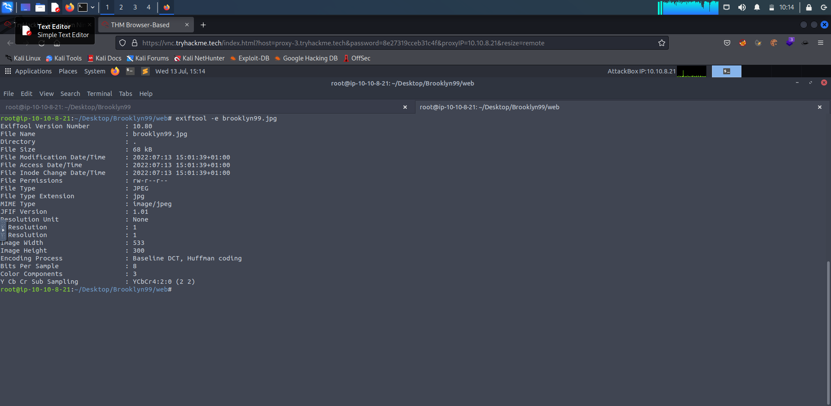

**Step 10:**

**Now we installed steghide to check about the image.**

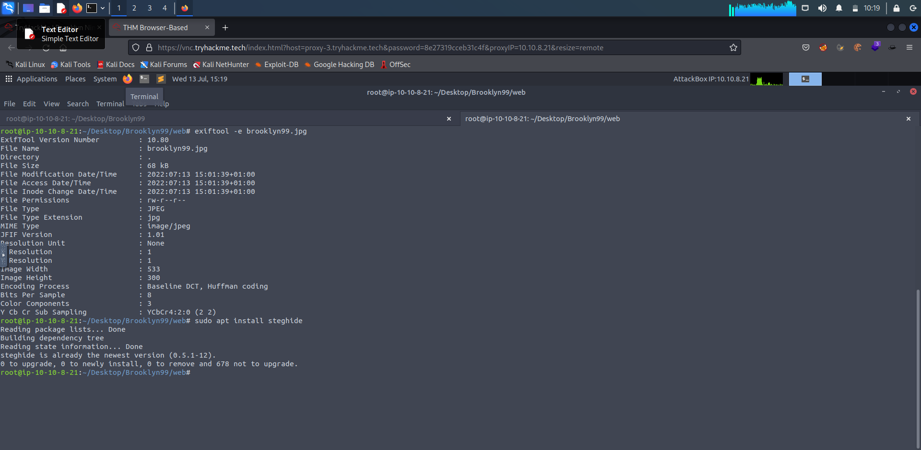

**Step 11:**

**Now with the help of -help command we checked the details of steghide.**

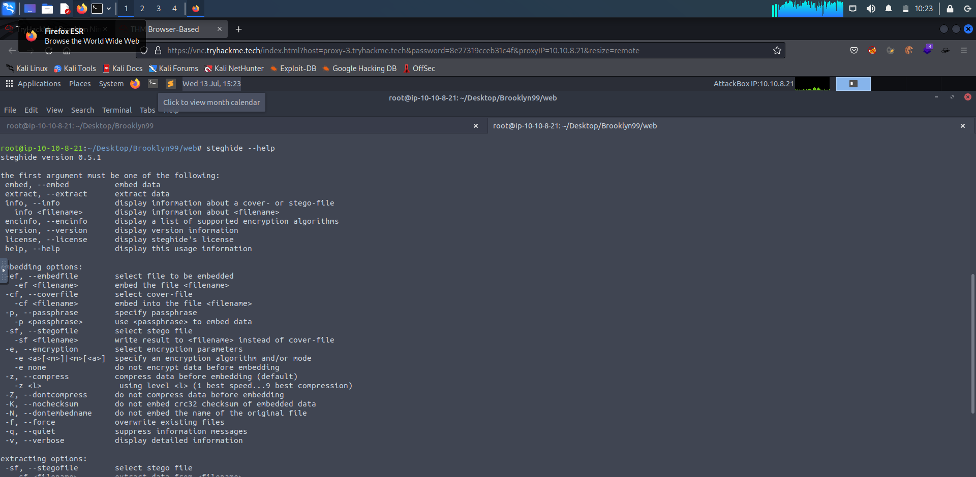

**Step 12:**

**Now we installed stegseek and stegosuite**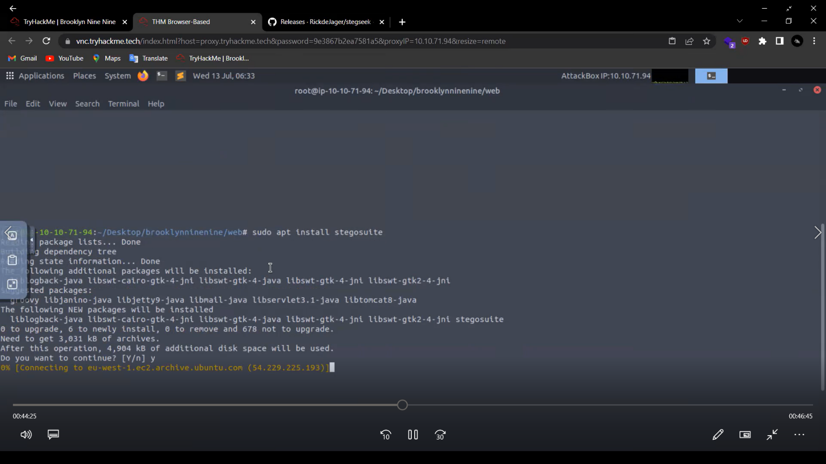

**Step 13:**

**Now with the help of hydra tool we will find out the password. Hydra toll is used for brute forcing method in order to crack the password.**

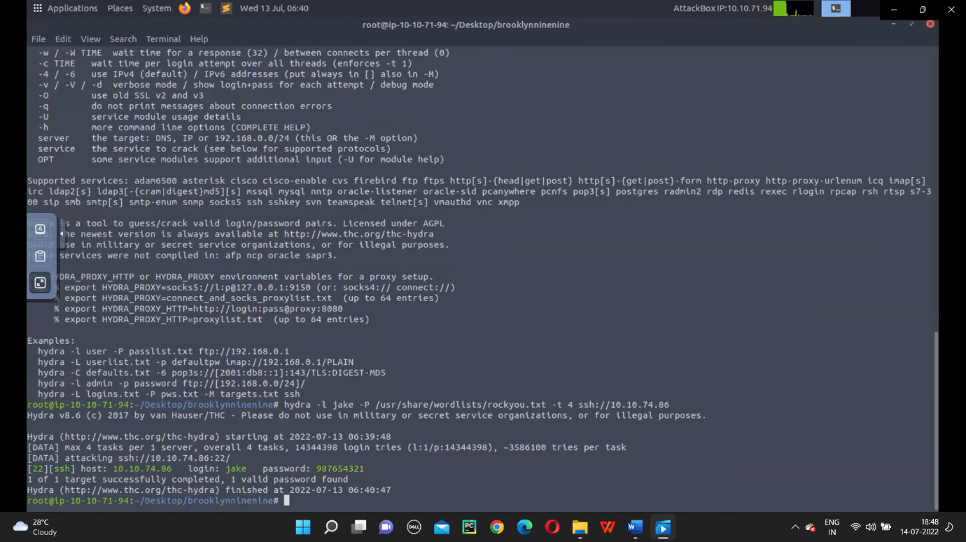

**Step 14:**

**Now we performed gobuster scan with the command dir -u http://** **10.10.99.206 -w /usr/share/wordlists/dirbuster/directory-list-2.3-medium.txt -t 10 in order to find more about directories.**

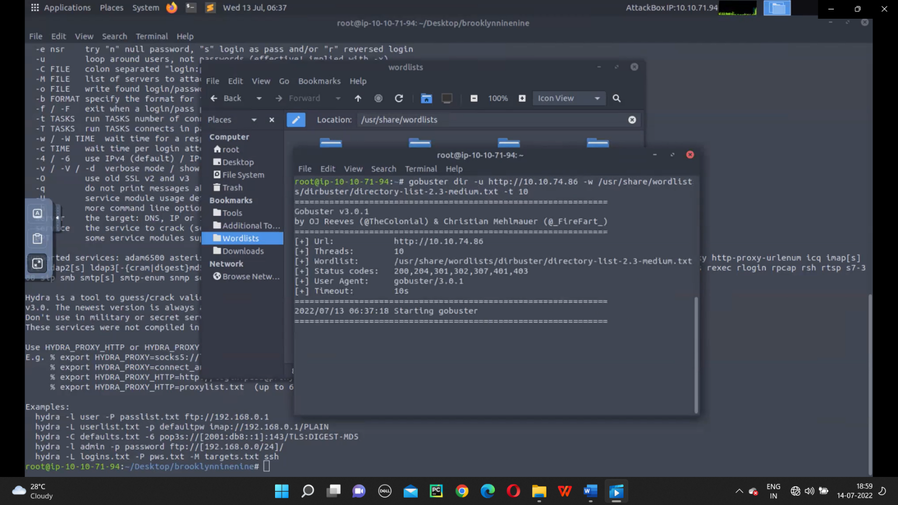

**Step 15:**

**Now with the help of hydra tool we got the usename and in order to get the password we use the following command hydra -l jake -P /usr/share/wordlists/rockyou.txt -t 4 ssh://** **10.10.99.206. And we found the password to be 987654321 and saved it in subl.**

**Then using ssh** [**jake@10.10.99.206**](mailto:jake@10.10.99.206) **command we confirmed the password and got the initial shell.**

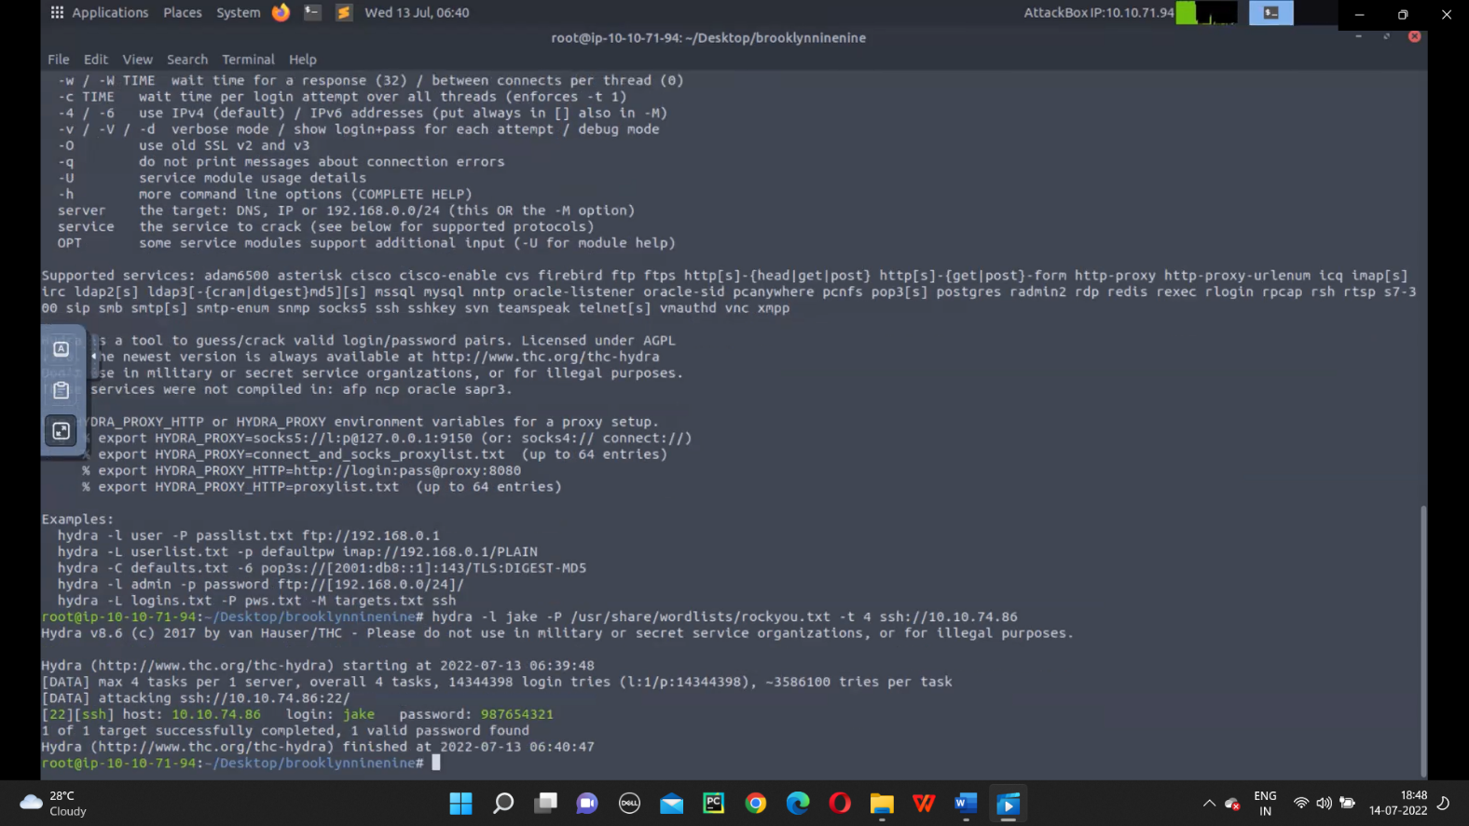

**Step 16:**

**With the help of ls command, we found that there is total three users Amy, Holt and Jake. Now with the help of cd holt we entered into Holt folder and found the following.**

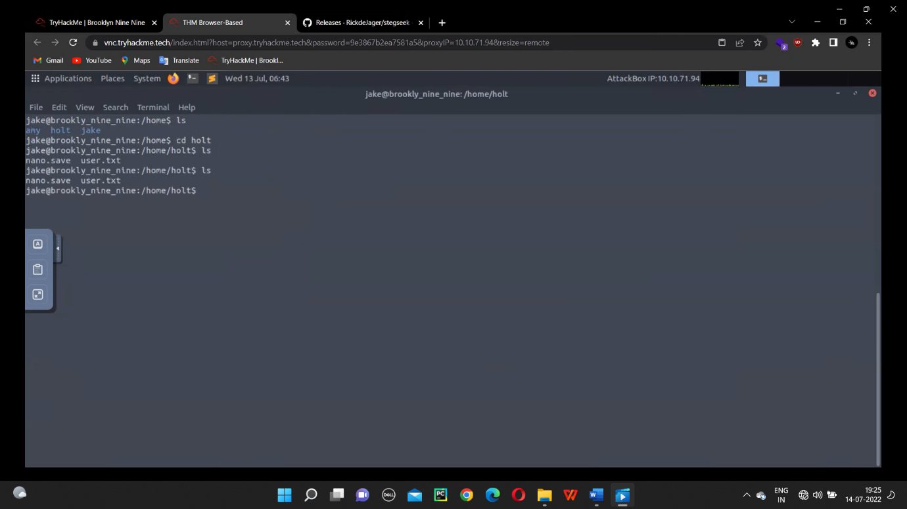

**Step 17:**

**Now by using cat user.txt command we got the user flag.**

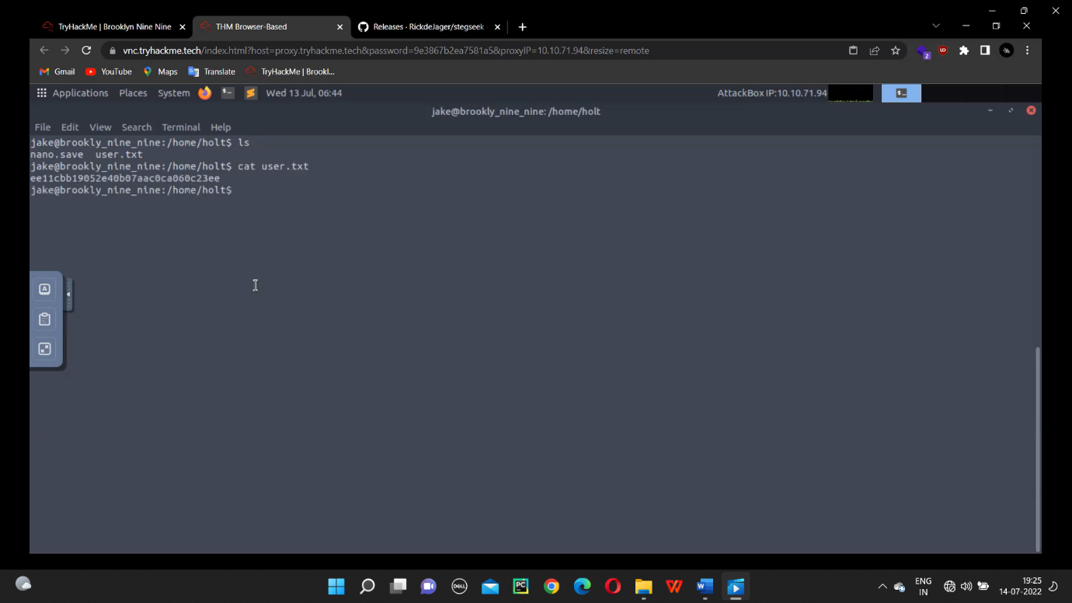

**Then with the help of less /root/root.txt command we got the root flag.**

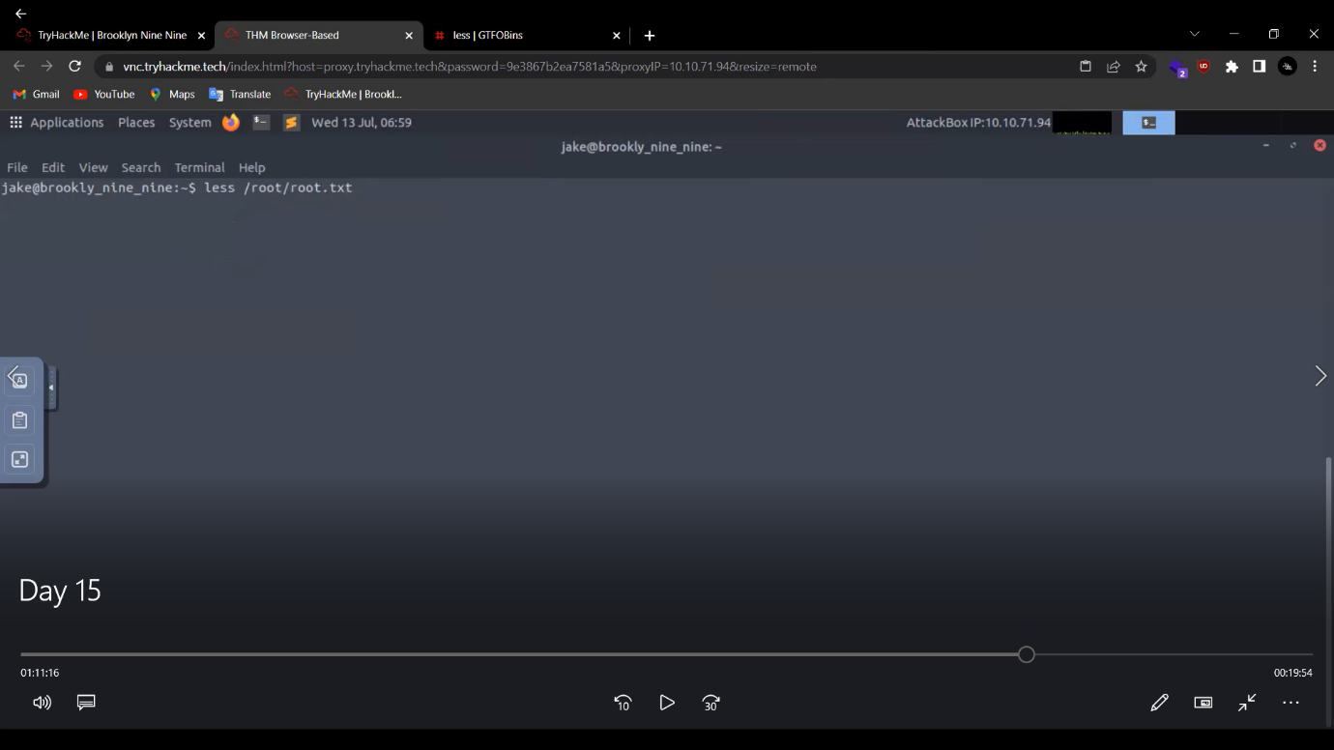

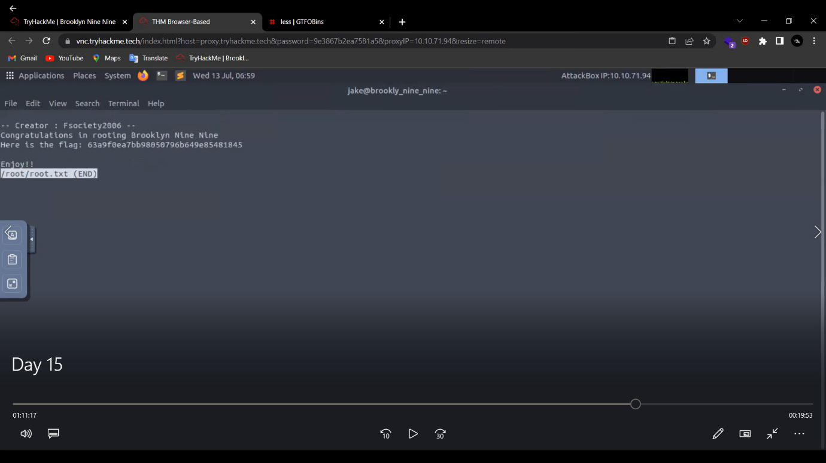

1. **Summary report on different steps performed on Linux Fundamentals.**

**Step 1:**

**To get the output as Try Hack Me we used echo command as echo ‘TryHackMe’and the output displayed.**

**To know the username, we used whoami command.**

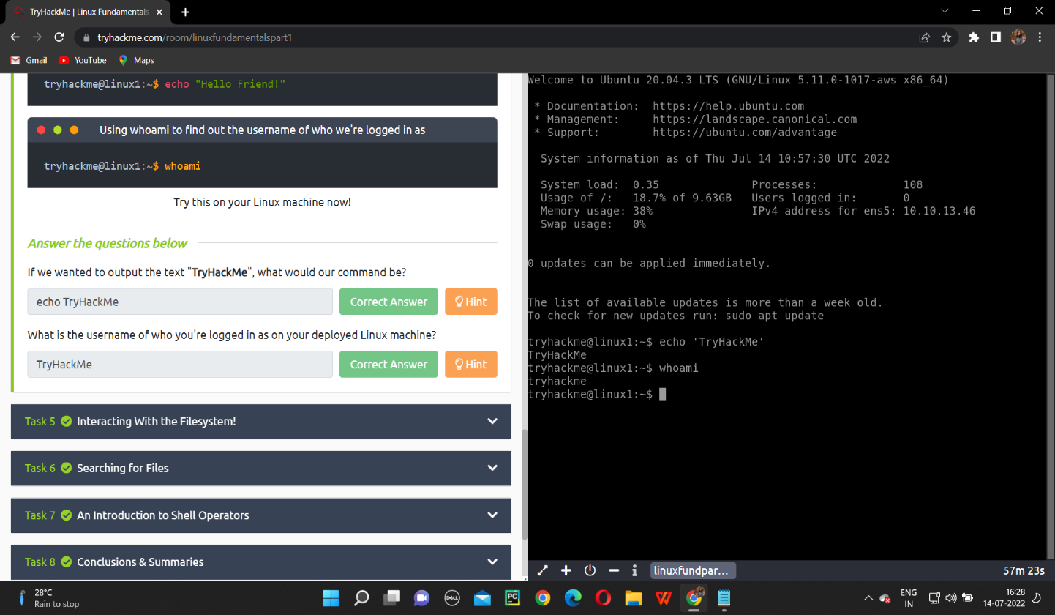

**Step 2:**

**To know the number of folders we used ls command and in order to check the file in the directory we used cd command as cd folder4.To know the contents, we used cat command and for the path we used pwd command.**

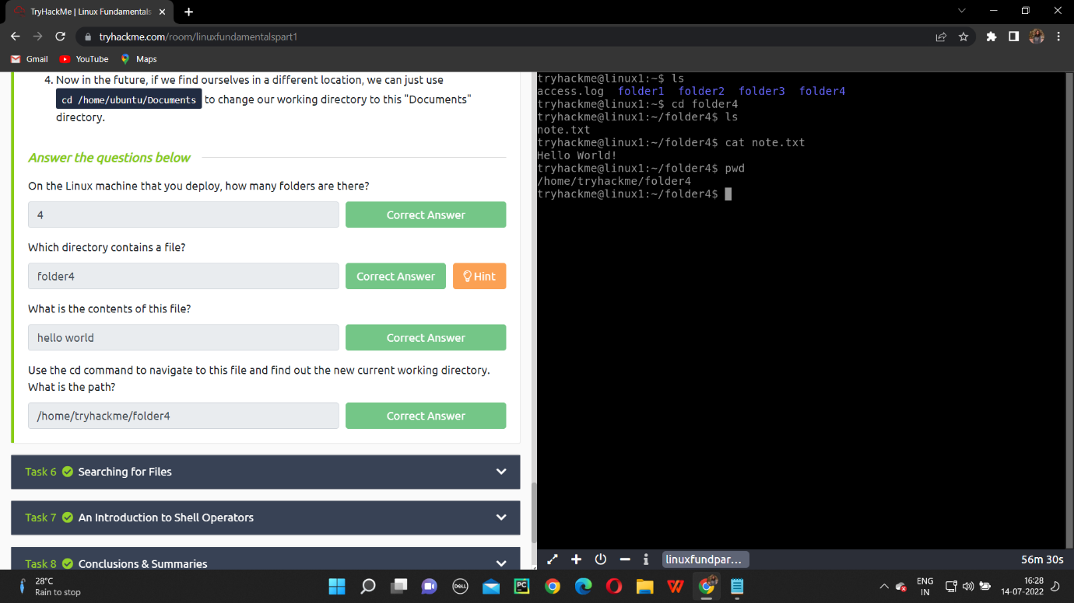

**Step 3:**

**Here we used grep command as cat access.log | grep ‘THM’ to get the flag.**

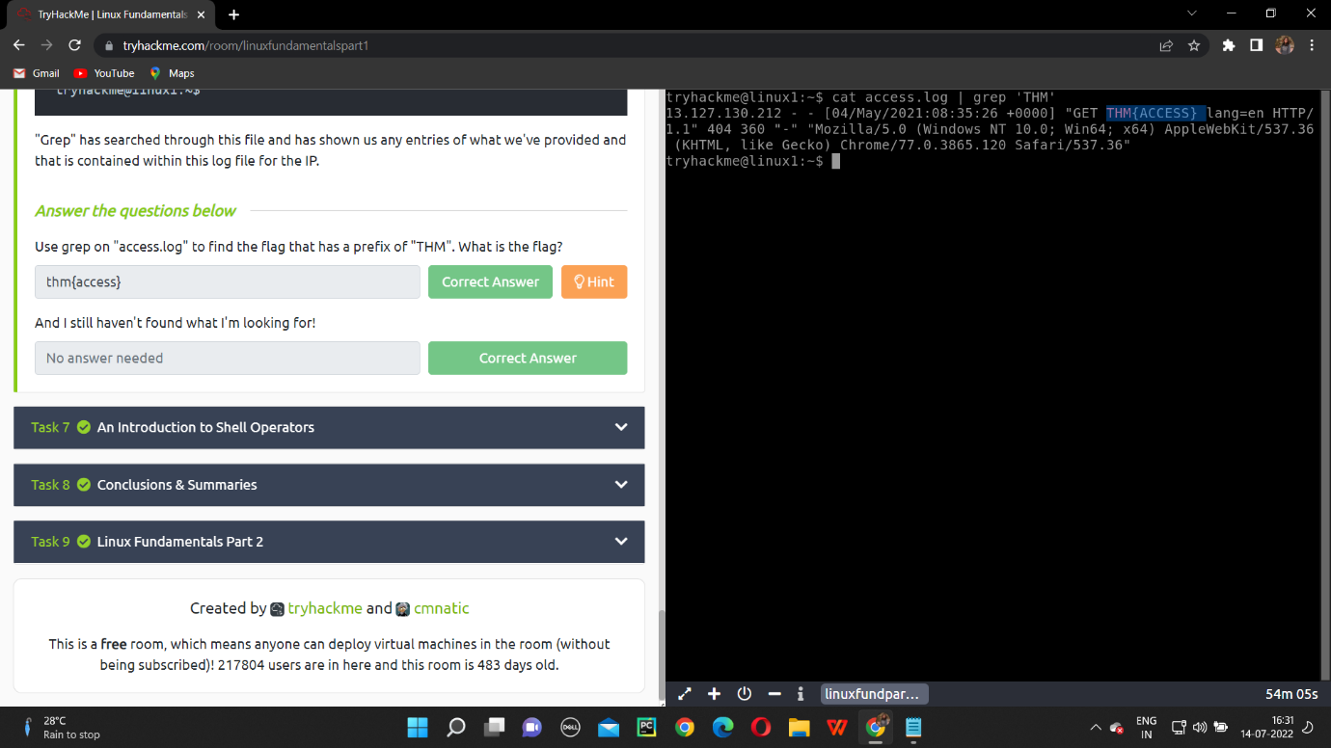

**NAME: I PRASANTI**

**SIC: 20BCEA56**

**BRANCH: CEN**